Date: May 12, 2014
City of New Bedford
133 William Street, Room 304
New Bedford, MA 02740
ATTN: Sarah Porter
Re: Sassaquin Pond Total Phosphorus Study
Dear Sarah:
Normandeau is pleased to provide you with the results of our 2013 total phosphorus study of Sassaquin Pond. First, we present the monthly data that we collected from June through November 2013. Then, we provide a discussion of those data and an assessment of significance relative to Sassaquin Pond water quality. We end with conclusions and some recommendations for future study to better understand the phosphorus regime in the pond.
BACKGROUND
Sassaquin Pond is a 38.4 acre (15.5 hectare) kettlehole pond located in New Bedford, MA (Figure 1). With an estimated volume (based on bathymetry provide in Baystate 1987) of 19,320, 640 ft³ (547,200 m³) and a mean depth of 11.6 ft (3.5 m). The pond has no permanent, natural inlets or outlet, but there are numerous stormwater inflow pipes and one overflow outlet pipe. In recent years, the pond has reportedly experienced algal blooms of increasing frequency and severity, especially in the fall. Fall algal blooms can be triggered by cooling lake temperatures that leads to and ultimately results in “fall overturn” with the associated entrainment of nutrient-enriched hypolimnetic waters into a deepening epilimnion. It was postulated that the same process could be leading to fall algal blooms in Sassaquin Pond, so the purpose of this study was to document the total phosphorus regime over the course of a summer/fall season.
We sampled the pond once per month from late June until mid-November. Sampling was conducted in the same location for each event which was in the approximate deepest part of the pond (see Figure 1). During each sampling event, we measured dissolved oxygen and temperature at one-meter intervals, top to bottom. In addition, we collected discrete water samples from the epilimnion and hypolimnion for laboratory analysis for total phosphorus. The epilimnion sample was collected by 4 to 5 m epilimnetic core while the hypolimnion sample was collect from a single location, approximately 1 m from the bottom. Samples containers and samples were delivered and picked up at our Falmouth, MA office by courier from Alpha Analytical of Westborough, MA which was the laboratory that did the total phosphorus analyses.

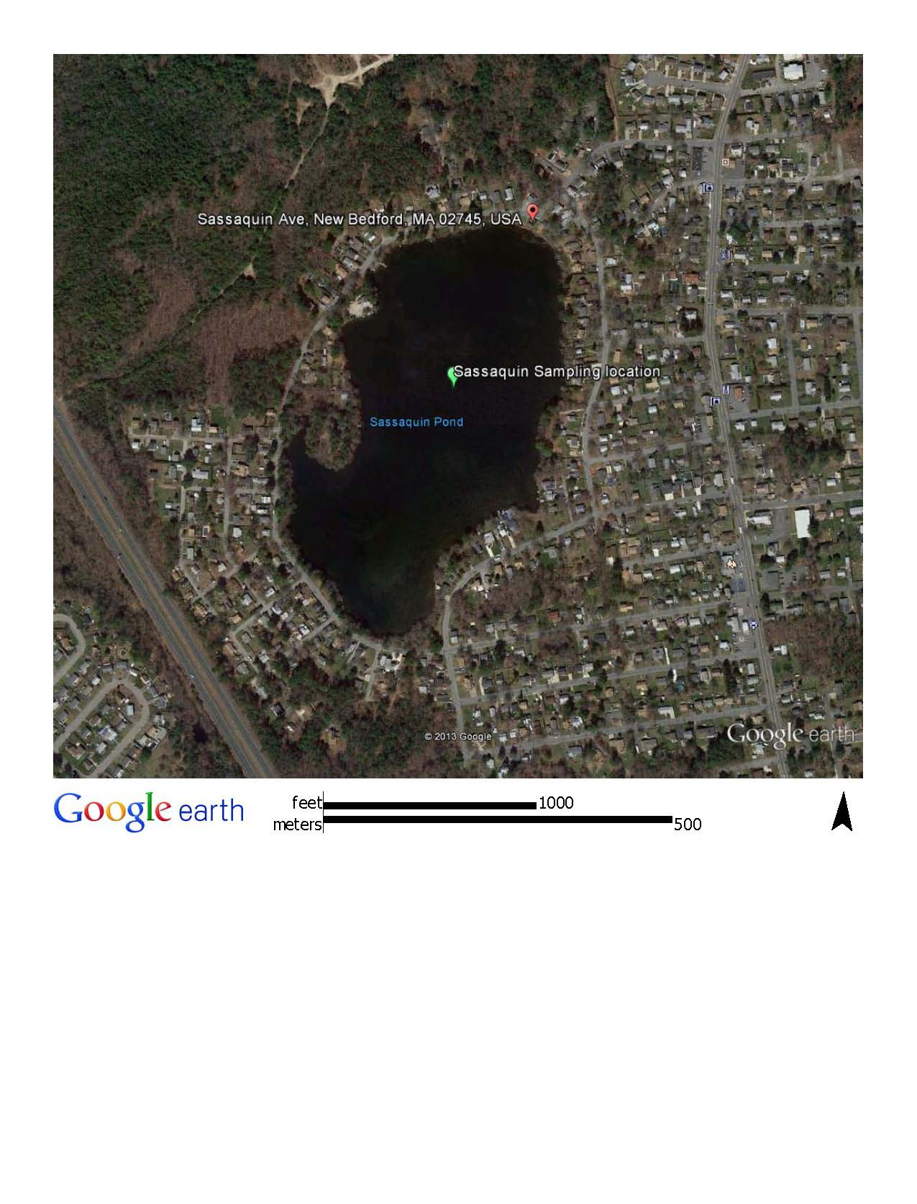
Figure 1. Sassaquin Pond Location Map
RESULTS
Temperature and dissolved oxygen. Results of our monthly dissolved oxygen and temperature measurements are provided in Figure 2. As expected, there were significant differences in both parameters between surface and bottom waters. During the late June sampling event, temperature near the surface was more than 27°C (~81°F), but temperature dropped rapidly and steadily below 1 m to about 13°C (55°F) near the bottom, indicating substantial and stable thermal stratification. Temperature at 4 m was a bit less than 21°C (~70°F). Dissolved oxygen displayed similar trends, with concentrations ranging from approximately 7 to more than 9 mg/l in the upper 3 m, then dropping rapidly to 1 mg/l or less from 5 m below the surface to the bottom at a depth of slightly more than 7 m.
By mid-July, the surface temperature was measured at slightly greater than 28°C (~82°F) and was in excess of 26°C (~79°F) down to 3 m. Below 3 m, temperature again declined rapidly to approximately 12°C (~54°F) near the bottom. Temperature at 4 m had risen to 24°C (~75°F). Dissolved oxygen concentrations were similar to June’s measurements. Levels were uniformly at ~8 mg/l in the upper 3 m of the water column and essential at zero below 6 m. At 5 m, dissolved oxygen remained at June’s levels, about 1 mg/l.
By the middle of August, temperatures in the surface waters had cooled to ~24°C (~75°F), while temperatures in deepest waters remained almost identical to July measurements. Temperature at 4 m was very similarly to all surface waters while at 5 m, temperature had risen to about 21°C (~70°F). Dissolved oxygen levels were also similar to July’s measurements, although dissolved oxygen was around 9 mg/l in the surface waters and the anoxic zone (dissolved oxygen ~0 mg/l) had increased its size to include the 5 m level.
By September 20, surface water temperatures had declined to less 20°C (~68°F). While temperature in near-bottom waters remained the same, the temperature at 6 m had increased to approximately 18°C (~64°F) and the lake depths less than 5 m were essentially isothermal. Dissolved oxygen levels were approximately 10 mg/l in surface waters and remained at ~0 mg/l below 6 m. At 5 m, however, dissolved oxygen concentrations had increased from near zero to greater than 5 mg/l.
By mid-October, late temperature was nearly isothermal, top to bottom, varying only from 15.9°C (~61°F) at the surface to 15.4°C (~60°F) at the bottom. Dissolved oxygen levels were similarly uniform, varying from approximately 10 mg/l at the surface to ~8 mg/l at the bottom. In November, temperature and dissolved oxygen pattern remained similar to October with temperature ranging from ~7°C (~45°F) at the surface to ~6°C (~43°F) near the bottom and dissolved oxygen concentration at ~11 mg/l, top to bottom.
Total phosphorus. Results of the total phosphorus tests are presented in Figure 3. In late June, total phosphorus concentration in the epilimnion was 371 parts per billion (ppb), while the concentration near the bottom was considerably less at 84 ppb. In July, the epilimnion concentration had declined to 220ppb, but the near-bottom concentration had risen to 106 ppb. In August and September, the epilimnion total phosphorus levels continued to decline to 181 and 114 ppb, respectively, while the near-bottom concentrations continued to increase slightly in August (111 ppb)

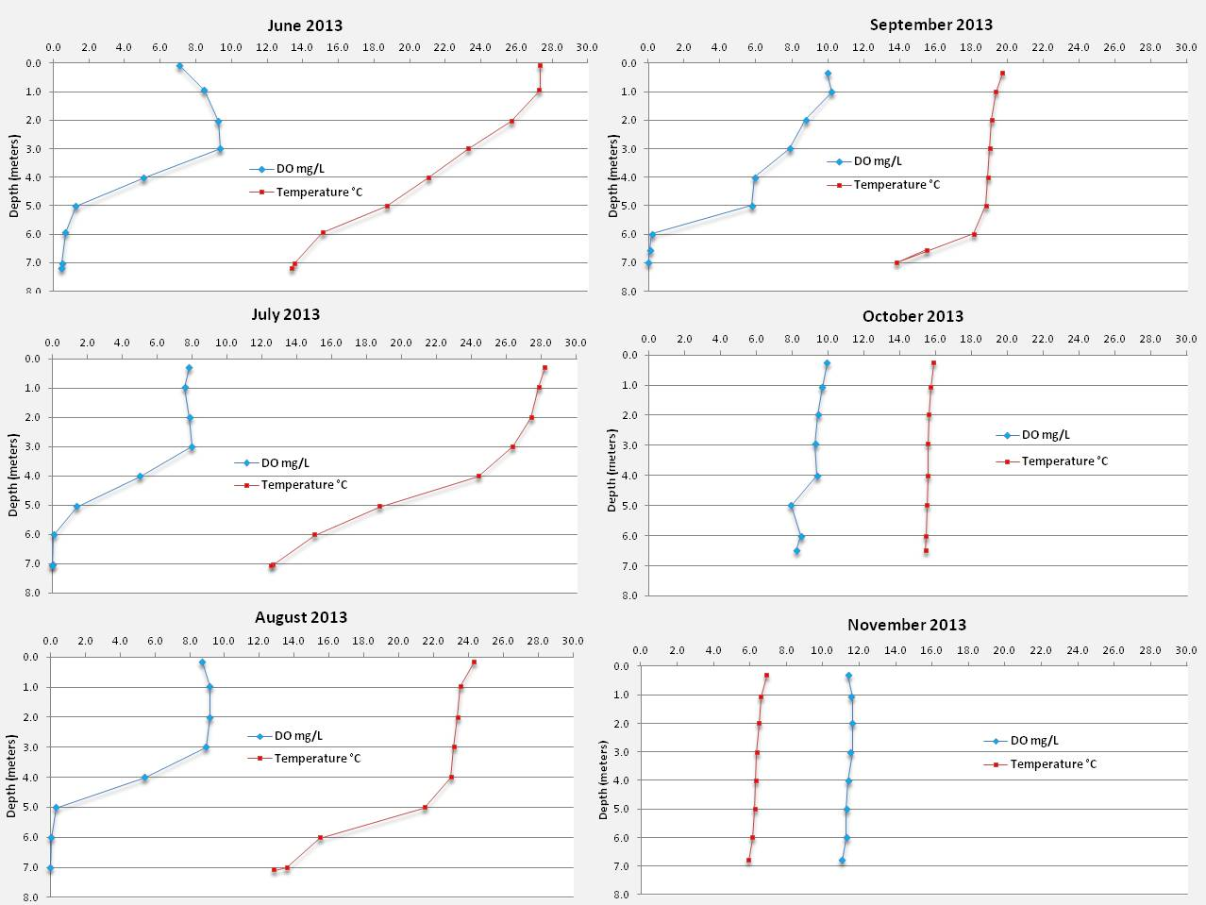
Figure 2. Monthly dissolved oxygen and temperature measurements – Sassaquin Pond, 2013.
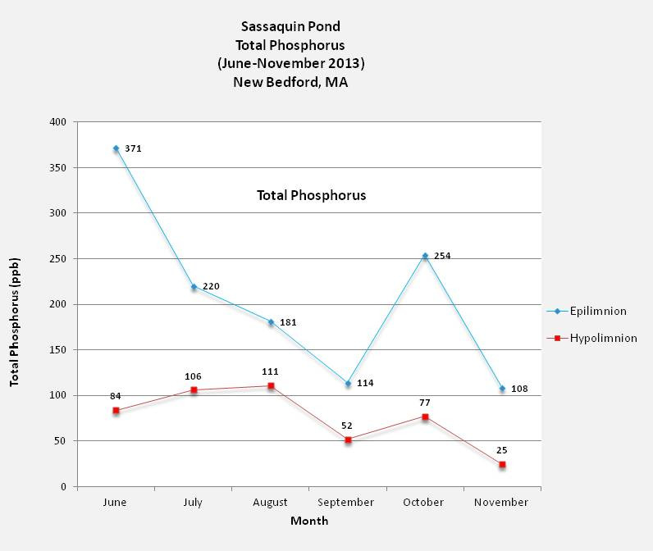Figure 3. Monthly total phosphorus concentrations – Sassaquin Pond 2013
and then declined sharply in September (52 ppb). In October, total phosphorus increased in both the epilimnion and near-bottom waters (254 and 77 ppb, respectively), but then declined sharply again in November (108 ppb in the epilimnion and 25 ppb at near-bottom) to the lowest levels of the monitoring period in both sampling locations. It is interesting to note that total phosphorus was always higher in the epilimnion that in the near-bottom waters, even in the fall when the pond was isothermal and therefore not thermally stratified.
ANALYSIS
These data provide a seasonal overview of the temperature, dissolved oxygen and total phosphorus regime in Sassaquin Pond during the 2013 summer/fall period. Some of the data were entirely consistent with prior expectations, based on the anecdotal information we had regarding Sassaquin Pond water quality. Some data are not consistent with expectations; without more definitive studies, we can only speculate as to why. With respect to the observed patterns of temperature and dissolved oxygen, both measures behaved as expected. In lakes that are deep enough to stratify (and Sassaquin Pond clearly is), we expect to find warmest temperatures in the surface waters (the epilimnion) during the “summer” stratification period, colder temperatures in the bottom waters (hypolimnion), and a transition zone somewhere in the middle (termed the metalimnion). The epilimnion tends to become deeper during the summer, primarily due to wind events that gradually entrain metalimnetic waters into the surface waters and during the fall when slowly cooling surface water temperatures become the same as progressively deeper temperatures, thereby gradually eliminating temperature differences that cause stratification. Eventually, most all lakes (in the temperate zone) that stratify become isothermal throughout the entire water column during the fall. This phenomenon is often called fall turnover. Fall turnover simply means that mixing can and does occur from top to bottom in a lake or pond, because density differences that create stratification are eliminated during this time. The thermal regime found in Sassaquin Pond was entirely predictable and expected and displayed all of the thermal characteristics described above.
With respect to dissolved oxygen, concentrations found in Sassaquin were also identical to expectations. The capacity of water to “hold” dissolved oxygen is inversely related to temperature, and in pristine, nutrient-poor lakes (termed oligotrophic) that contain minimal oxygen-producing or demanding substances, dissolved oxygen concentrations would be expected to range from approximately 8 mg/l at the surface during the summer to about 10.5 mg/l at the bottom. In enriched lakes (termed eutrophic), where algal blooms are present, dissolved oxygen behaves quite differently. Typically, nutrient-rich lakes would have surface water dissolved oxygen levels that are higher than in nutrient-poor lakes, and in bottom waters, concentrations are lower and perhaps even absent. As with all plants, algae produce oxygen during the daylight hours but use oxygen at night. Because there are few other natural means of creating supersaturated conditions in lakes, elevated levels of dissolved oxygen (termed super-saturation) are almost the result of algal growth. Under-saturation generally results from something in the water that has an oxygen demand, usually labeled “biochemical oxygen demand” or BOD. In the case of lakes, the primary sources of BOD are respiring algal cells (algal cells that have settled below the photic zone and can no longer grow by photosynthesis) and organic material most commonly derived from dead algal cells. This oxygen demand is highly variable in lakes, depending on their nutrient status, but in eutrophic lakes, it is common to have dissolved oxygen levels entirely depleted in the deepest waters during the summer period.
In June, measured dissolved concentrations in Sassaquin Pond exceeded 9 mg/l at the 2 and 3 m depth and were less than 1 mg/l below 5 m. These levels suggest that algae growth is influencing the dissolved oxygen regime in Sassaquin Pond, causing dissolved oxygen super-saturation in the upper portion of the water column and highly under-saturated conditions in the near-bottom waters. It is expected that excessive algal growth is the primary factor contributing to dissolved oxygen super- and under-saturation in Sassaquin Pond. In fact, super-saturation of dissolved oxygen was evident a varying levels during July, August and September as well, reinforcing the conclusion that algal growth strongly influences dissolved oxygen levels in Sassaquin Pond throughout the growing season.
With respect to total phosphorus, levels at all depth are extraordinarily high and are sufficient to create hyper-eutrophic conditions. Conventional limnology suggests that for most temperature lakes, total phosphorus levels less than 10 ppb would define oligotrophic or low nutrient-level lakes, 10-20 ppb would describe mesotrophic or moderate nutrient-level lakes and levels in excess of 20 ppb would support eutrophic or high nutrient-level conditions. In early summer, Sassaquin Pond had total phosphorus levels more than 15 times higher than the lower eutrophic level, indicating highly enriched conditions. As the season progressed through summer and early fall, total phosphorus levels declined sharply, possibly indicating that algal uptake of phosphorus and subsequent settling of algal cells out of the photic zone continually stripped total phosphorus from the surface waters. Total phosphorus levels in the hypolimnion were substantially lower than in the epilimnion for the entire period, but especially during June. At this time, the concentration at depth was only 84 ppb, compared to 371 ppb in the epilimnion. Hypolimnetic concentrations increased gradually but modestly through August and then declined substantially during September. Both epilimnetic and hypolimnetic observed trends are consistent with expectations for enriched lakes, but a much more significant increase in hypolimnetic total phosphorus would have been expected, given the lack of dissolved oxygen at depth (phosphorus release from the sediment is enhanced by anoxic conditions).
In October, there was a sharp rise in total phosphorus concentration in surface waters, followed by another sharp decline in November. At the same time, concentrations in the hypolimnion rose, but not nearly as significantly as in the epilimnion. In November, total phosphorus levels in both the epilimnion and hypolimnion declined sharply to the lowest levels of the monitoring period.
One would typically expect that increases in total phosphorus levels in lakes during the fall period would result from one or two things – increased phosphorus loading from external sources due to fall runoff events and/or increased internal loading from entraining phosphorus-enriched hypolimnetic waters during fall turnover. In this case, neither seems to be a major contributing factor. Review of the streamflow data for the nearby Paskamanset River did not reveal a significant runoff event between our September and October sampling dates, indicating that external loading was probably not the source of elevated phosphorus levels in October. Similarly, total phosphorus concentrations in the hypolimnion do not appear to be high enough to explain the substantial increase in epilimnetic total phosphorus concentraton. Using the depth contours provided by Baystate (1987), we determined that the volume of the pond below 5 m is only about 16% of the total pond volume. If this entire volume was mixed into the whole pond during fall turnover, the average concentration of the entire hypolimnion would have had to have been ~250 ppb to yield the increase in total phosphorus levels observed in the October epilimnion. Clearly, the data do not support this since hypolimnetic total phosphorus concentration did not exceed 111 ppb at any time during the monitoring period. While we can only speculate as to the cause of the sharp October rise in total phosphorus, it is possible that algal cells (and perhaps other settled solids) and associated dissolved phosphorus that had accumulated on bottom were re-suspended during fall turnover, leading to elevated total phosphorus levels in the pond.
In November, total phosphorus concentrations dropped sharply again in the pond and at all depths, but the cause of this drop is also unknown. If the event that caused the rapid increase in October was a bottom-related phenomenon, these materials would have been residing in an anoxic environment. Fall overturn would have introduced oxygen to all depths of the pond (which is clearly shown in the October and November data) which in turn could have led to the formation of phosphorus-scavenging iron oxides and subsequent relatively rapid settling of the phosphorus rich iron oxide floc. Clearly the phosphorus found in the water column in October came from somewhere, but by November, it was gone. Some type of internal mechanism seems a logical suspect, but we cannot say definitively what that mechanism was.
That said, the patterns of total phosphorus levels seen in Sassaquin Pond suggest that phosphorus loading from storm water may be playing a more important and perhaps overriding role in the nutrient status of the pond. In typical lakes and ponds, their nutrient status during the summer and fall is established at spring overturn and by spring runoff. During this time, total phosphorus concentrations are typically identical, top to bottom, because the pond is mixing top to bottom during this un-stratified period. Later in the year, after the pond becomes stratified, total phosphorus levels tend to decrease in the epilimnion and increase in the hypolimnion as a result of different biological processes affecting nutrient status in the two water zones. We observed similar trends in Sassaquin, but in June, total phosphorus levels in the epilimnion were nearly 5 times higher than in the hypolimnion which is inconsistent with the expectation discussed above. In looking at the weather record for spring 2013, we note that the area experienced a relatively dry April and early May, so during the time the pond was becoming stably stratified, there was not much external loading to the pond. However, heavy rain events occurred in mid-May through mid-June that likely introduced significant phosphorus loads to the pond. Since the pond was already stratified, this loading was likely reflected solely in the epilimnion and not at all in the hypolimnion, resulting in the greatly differing values we saw in June. If this indirect observation is true, then it would appear that the primary efforts to improve water quality in Sassaquin Pond should focus on controlling external nutrient loading. Since there are no natural tributaries, control efforts would have to focus on loading from stormwater runoff outfall structures.

CONCLUSIONS AND RECOMMENDATIONS
Total phosphorus, dissolved oxygen and temperature data collected in Sassaquin Pond from June to November 2013 suggest that the pond is hyper-eutrophic and stably stratified during the summer and early fall season. Nutrient levels were extraordinarily high in the epilimnion in June, but declined steadily (except for October) throughout the study period. During October, total phosphorus levels increased dramatically, probably in response to fall turnover and then quickly declined to their lowest levels of the monitoring period in November. Total phosphorus concentrations in the hypolimnion were substantially lower than levels in epilimnion during each month. As expected, hypolimnetic levels rose slightly during the summer, probably in response to reduced dissolved oxygen levels, but then paralleled epilimnetic levels, rising in October and dropping to their lowest levels in November. Surprisingly, measured total phosphorus levels in the hypolimnion did NOT appear to be sufficient to significantly influence total phosphorus levels in the whole lake during fall overturn. Rather it is postulated that a near-bottom accumulation of decaying algal cells, other settled solids and associated dissolved phosphorus was re-suspended during fall overturn, resulting in sharp, albeit brief, increases in total phosphorus at all depths.
Given the total phosphorus patterns observed in the epilimnion and the hypolimnion, it is speculated that external nutrient loading rather than internal loading is the primary source of total phosphorus to Sassaquin Pond. It is known that the principal source of surface runoff to the pond is from stormwater outfalls, but the relative contribution of each is unknown. It is therefore recommended that a stormwater monitoring program be implemented to better define the role of stormwater runoff in the nutrient dynamics of Sassaquin Pond and to help target remedial efforts toward those outfalls that are contributing the greatest load. In addition, it is recommended that a concurrent, more intensive in-lake sampling program be undertaken to better define nutrient and algal behavior in the lake and relate them to both external and internal influences. A definitive program would require sampling from at least spring turnover to fall turnover and preferably for one full year.
Thank you for the opportunity to assist with Sassaquin Pond. If you have any question or we can be of further assistance, please don’t hesitate to get in touch.

Sincerely,
NORMANDEAU ASSOCIATES, INC.

Senior Water Resources Engineer

Baystate Environmental Consultants. 1987. A Preliminary Evaluation of Sassaquin Pond and its Watershed. Prepared for the City of New Bedford. 42pp.

